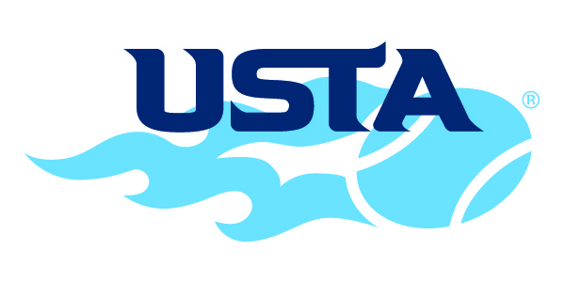
Media Credentials Request

2019 USTA Boys' 18 and 16 National Championships

Name(s): ______________________________________________________
______________________________________________________
Representing: __________________________________________________ Address: _______________________________________________________
City, State, Zip: __________________________________________________
Phone: __________________________ FAX: _________________________
Email: _________________________________________________________
Number of Press Badges Needed: ________

PHOTOGRAPHERS
Commercial photographers and/or any individual that sells photographs:
Your request for and acceptance of an on-court press credential acknowledges
your consent to provide photographs as requested to the USTA office at no
charge for the purpose of promoting the tournament through posters, brochures, web sites, or any other means as determined by the tournament director. The USTA office will not sell or distribute your photographs in any other manner. Photo credits will be displayed wherever possible.
Photographer Acknowledgement: ____________________________________

Please return this form by Thursday, August 1 to:
Fax: (269) 337-7385
E-mail: mriley@kzoo.edu
Mail:
USTA Nationals, Kalamazoo College, 1200 Academy Street, Kalamazoo, MI 49006

Rev 7/19

