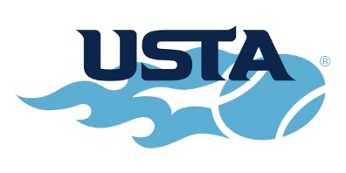
USTA Boys’ 18 & 16 National Championships

TICKET ORDER FORM

To purchase Patron tickets, please fill out this form and mail to the Tournament Office. You may also place your order by calling the Tournament Office at (269) 337-7343. To pay by credit card please visit: www.kzoo.edu/usta/tickets.php. Advance tickets can be reserved until July 29. Beginning August 5, tickets may be purchased and picked up at the Stowe Stadium Acker Lane ticket booth.

Tournament Patron (August 5-14) includes reserved seats for the 10 day tournament and your name printed (if desired) on the Patron page in the Tournament Draw Sheet.

Reserved Seating- Under Canopy
Ticket Type | Price | # of Tickets | Total $ Amount
Tournament Patron* | $100* |  | $
Youth Patron (K-12)** | $50** |  | $
Semi-Finals (Saturday, August 13) Adult | $15 |  | $
Semi-Finals (Saturday, August 13) Student | $10 |  | $
Finals (Sunday, August 14) Adult | $15 |  | $
Finals (Sunday, August 14) Student | $10 |  | $
Donation or Gift |  |  | $
TOTAL |  |  | $
*$50 tax deductible
**$25 tax deductible
Please note: As of May 1, 2022, masks will be optional at the 2022 Boys’ Nationals. Mask and other COVID-related restrictions are subject to change. Please visit ustaboys.com and watch for signage at tournament for updates.
No
Yes
*May we list your name on the Patron Page in the Tournament Drawsheet?

If so, please print your name exactly as you wish it to appear in the Drawsheet:

First Name:_________________________ Last Name:________________________________________________

Address:_____________________________________________________________________________________

City, State, Zip:________________________________________________________________________________

Phone:____________________________ Email:_____________________________________________________

-No Ticket Refunds-

To Pay by Credit Card (No debit cards) visit: https://www.kzoo.edu/usta/tickets.php

You will receive an email receipt of the transaction

If paying by check, make payable to “Kalamazoo College - Tennis”

Mail to: USTA Nationals
1200 Academy Street
Kalamazoo, MI 49006

Daily tickets can also be purchased starting Friday, August 5 at the Stowe Stadium main entrance (Acker Lane).
Patron or Reserved tickets will be mailed in late July with the Patron Tax Receipt.
For questions regarding tickets or general tournament information, please call (269) 337-7343
Additional information available on Tournament website:
www.ustaboys.com

